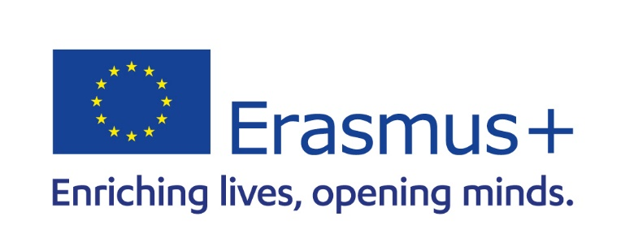**APPLICATION FOR ERASMUS+ SCHOLARSCHIP**

Munich Business School is part of the Erasmus program. Part of the program supports Study Abroad for Students (SMS = Student Mobility Services) at European universities who are part of the Erasmus network. Each year, MBS has to apply for an Erasmus grant which amount varies each year, depending on the EU funding available.

**Who can apply for Erasmus SMS?**

Any MBS student who is enrolled in a full-time program and studying abroad at an Erasmus partner university of MBS can apply for Erasmus grants (no Freemover Universities). The actual amount a student gets depends on the country of destination, the number of students going on Erasmus, as well as other award criteria (see below). Typically, students receive between EUR 1000 - EUR 2.500 per stay, which they can use freely. Please note: Students only can be funded for stays abroad in a country which is not their main country of residence (at the time when the Erasmus Grant Agreement is signed).

**What are the award criteria?**

A number of criteria will factor into the actual amount to the student:

* Academic standing (GPA or NC at MBS at the time of application)
* Social involvement (extracurricular engagement) at or outside MBS (mention in your CV)
* Financial need - explain (if available include proof; copy of Bafög or bank loan or other proof)
* Complete application “Request for Erasmus+”(page 2)

**How can I apply?**

*Submit the following application documents:*

1. **Request for Erasmus+ Form** (page 2) - completed and signed
2. **CV** (resume) in English
3. **Letter of Motivation** (1 page, explaining why you chose to attend an Erasmus university and what makes you a good candidate for the Erasmus grant, how you benefit from your stay at the university and how you meet the award criteria. Remember to include any extracurricular and curricular activities and/or provide information about your financial situation.)

**Deadline**

* **April 30** (for an exchange in **Fall** Semester)
* **August 31** (for an exchange in **Spring** Semester)
* Belated applications will NOT be considered
* Mail the application documents (in **one** PDF) to [outgoing@munich-business-school.de](mailto:outgoing@munich-business-school.de)
* For questions, please contact the Outgoing Department at MBS, International Center, [outgoing@munich-business-school.de](mailto:outgoing@munich-business-school.de)

**Request for Erasmus+**

Please fill in the requested information below so we can check your eligibility for receiving Erasmus**+** grants for your semester abroad.

**Personal Information**

|  |  |  |  |  |
| --- | --- | --- | --- | --- |
| First Name: |  |  | Last Name: |  |
| E-mail: |  |  | Phone Number: |  |
| Date of Birth: |  |  | Nationality: |  |

**Your MBS Program**

|  |  |  |
| --- | --- | --- |
| BA IB | MA IB | MA IMBM  MA IE  MA FIN |

|  |  |  |  |
| --- | --- | --- | --- |
| **Your current GPA (NC) at MBS:** |  |  |  |

**Do you have any special needs or handicaps?**

**Your Study Abroad Plans**

Semester/year you plan to go abroad(i.e. fall or spring/2026):       /

Name of university abroad/country:       /

Please indicate how many travel days you need/require in total to your study abroad destination and back:

Up to 6 travel days (for sustainable travel). Up to 2 travel days for standard travel if required

Only if applicable: I will travel sustainable (Bus, Train, Bicycle, Carpooling). In this case students will receive a higher travel allowance

Only if you travel sustainable: I submit the Honorary Declaration for Green Travel (separate document in Download Section on Study Abroad Portal)

|  |  |  |
| --- | --- | --- |
| Do you receive Bafög? Any scholarships? Do you have a bank loan or other student loan? |  | No  If Yes, please explain. |
| Are you a part of any MBS extracurricular activity? (e.g. Student Initiative, Buddy program, Study Fairs, Open House, Bachelor Assessment Day etc.)? |  | No  If Yes, please explain. |
| Please note there is the possibility of an additional/higher grant based on specific eligibility criteria (if none of the categories below applies to you, no action is required in this section). Please mark with a cross if applicable and send us the signed honorary declaration:  students with children  disabled or chronically ill students  working students  students from non-academic family background  Further information can be found in the “info sheet for additional funding”.  I submit the Honorary Declaration for additional funding (separate document in Download Section on Study Abroad Portal) | | |

Additional Comments?

|  |  |  |  |
| --- | --- | --- | --- |
| Student Signature (*jpeg or tiff format)*: |  |  | |
| Date (Day/Month/Year): |  | /      / |